|  |  |  |  |  |  |  |  |
| --- | --- | --- | --- | --- | --- | --- | --- |
| **Materia:** | Programación Web 4.0 | | | **Profesor:** | Ing. José Iraic Alcántar Alcántar | | |
| **Tema:** | 1. Web services | | | | | **Fecha:** | 20/02/2022 |
| **No Control:** | S18030183 | **Alumno:** | Salvador Yander Navarrete Gutiérrez | | | **Grupo:** | 078CA |

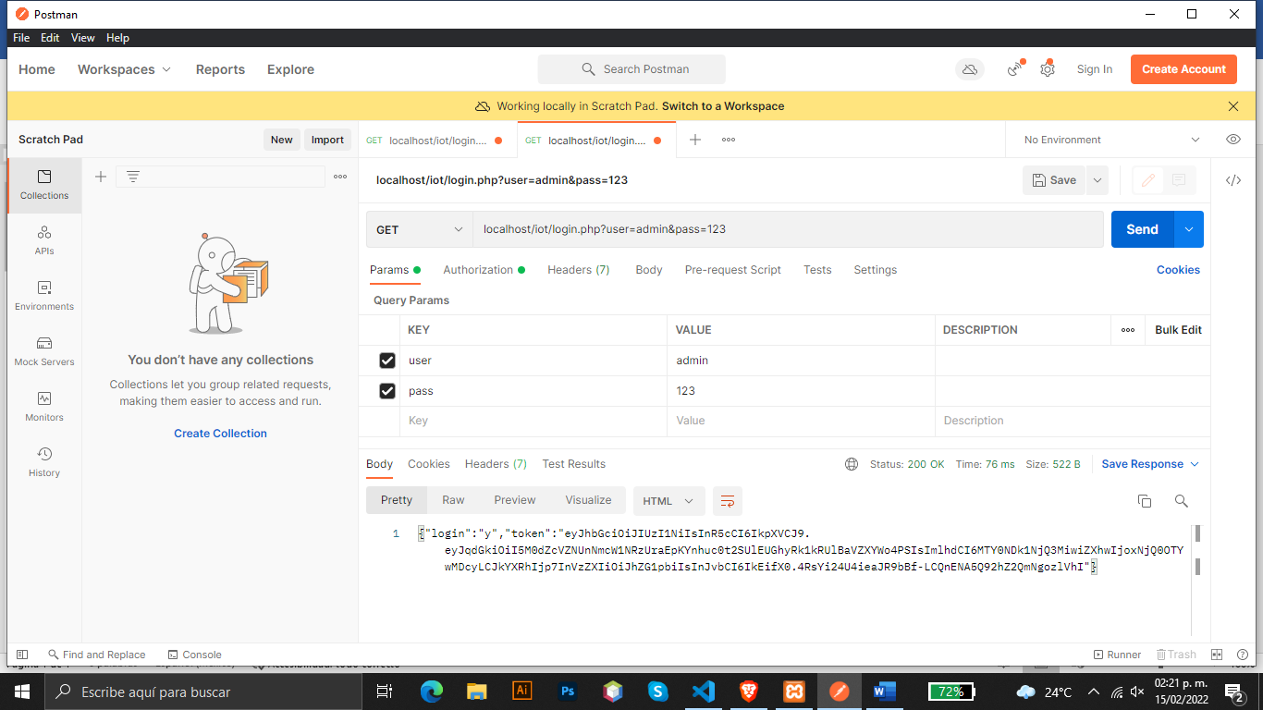

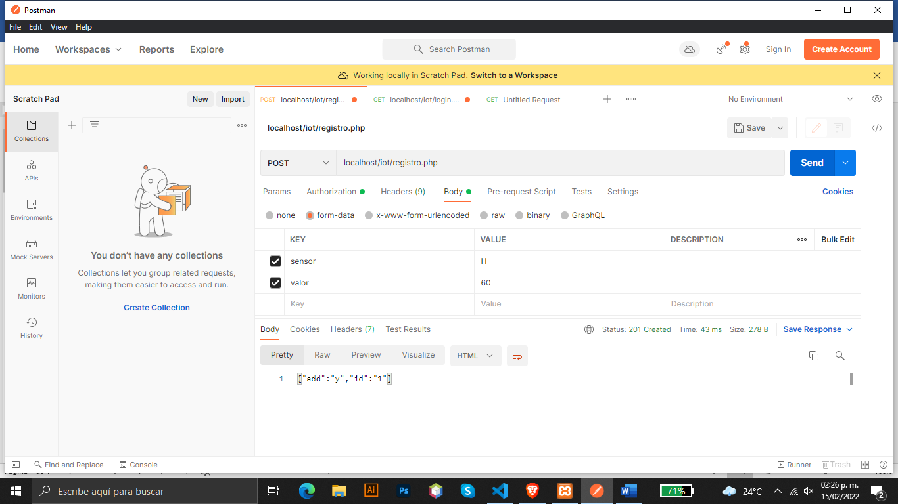

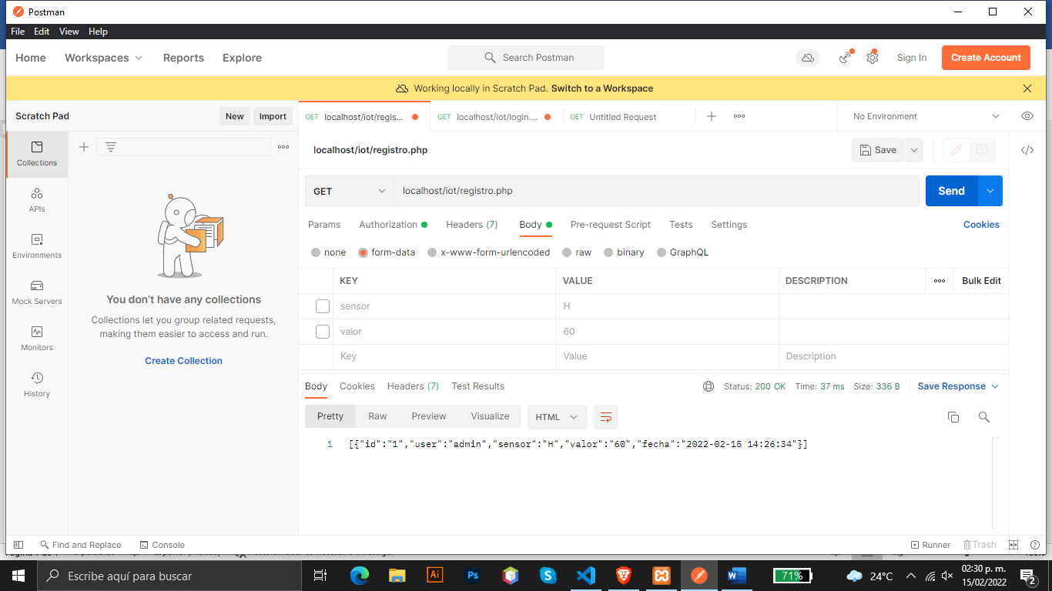

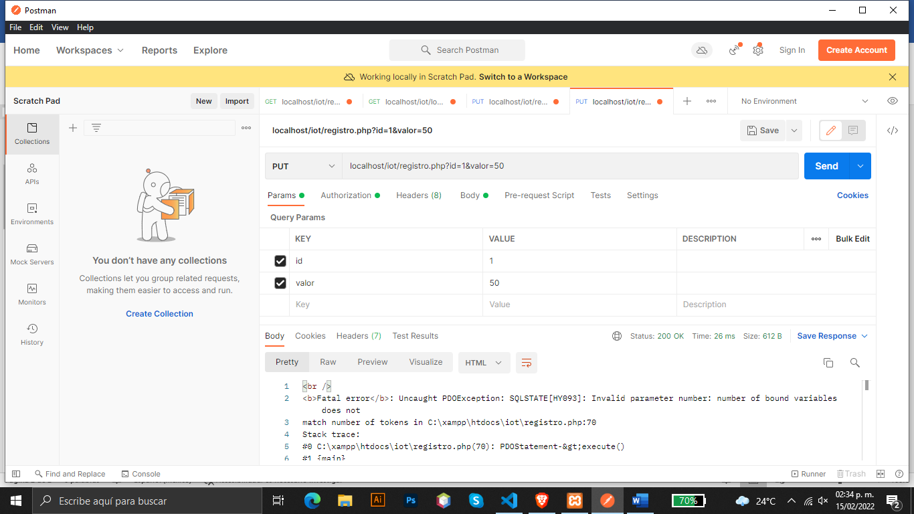

**Link de GitHub:**

<https://github.com/YanderN/smarthome>